**Achievements and Statistics Comparison between LeBron James and Michael Jordan**

**Boyuan Li1*, Chuhong2**

1.Woodberry Forest School, Virginia 55792, USA

2. School of Business, Xijing University, Xi'an, 710123, China

***\*Corresponding author*: *Boyuan Li, 26598745@gmail.com***

**Copyright:** 2025 Author(s). This is an open-access article distributed under the terms of the Creative Commons Attribution License (CC BY-NC 4.0), permitting distribution and reproduction in any medium, provided the original author and source are credited, and explicitly prohibiting its use for commercial purposes.

**Abstract:** This paper explores the comprehensive performance of LeBron James and Michael Jordan on the basketball court by comparing their scoring efficiency, organizational ability, defensive comprehensiveness, advanced data analysis and career durability. The study shows that although Jordan's historical status and outstanding achievements are undeniable, LeBron has demonstrated a more versatile basketball style with a longer career, a more comprehensive skill set and the ability to adapt to multiple positions. Through data analysis, this paper emphasizes LeBron's comprehensive performance in scoring, assists, defense and leadership, making him a more complete basketball player. Finally, this paper encourages readers to further think and form opinions on who is the greatest basketball player in history based on the data and analysis provided.

**Keywords:** LeBron James; Michael Jordan; Scoring Efficiency; Organizational Ability; Basketball Comprehensiveness

**1. Introduction**

**1.1 Research Background and Importance**

As one of the most popular sports in the world, basketball has produced countless great players, and LeBron James and Michael Jordan are undoubtedly the most representative figures among them. Michael Jordan became a symbol of basketball with his outstanding performance in the 1980s and 1990s, winning six NBA championships and five regular season MVPs, and is widely regarded as the "God of Basketball" [1]. Meanwhile, LeBron James rose to prominence on the 21st century stage, establishing himself as one of the most comprehensive players in basketball history through his successful performances on multiple teams, four NBA championships, and four regular season MVPs [2]. These players have not only achieved great success on the court, but also shaped the cultural landscape of basketball through their personal brands and social influence [3].

However, simply comparing their achievements through traditional means, such as the number of championships or MVP awards, is no longer enough to measure their true value and influence (see figure1). With the advancement of basketball statistics, more and more advanced data indicators are being used to more accurately evaluate a player's comprehensiveness and efficiency. These data cover not only points and rebounds, but also various aspects such as organizational ability, defensive impact, and contribution to team success [4]. Therefore, an in-depth analysis of the achievements and data of LeBron James and Michael Jordan can not only deepen our understanding of these two great players, but also help provide more objective data support for the battle for the "greatest player" in basketball history.

**1.2 Research Objectives**

This study aims to explore the performance of LeBron James and Michael Jordan in different technical fields through in-depth analysis of their basketball career data, and to evaluate their respective comprehensiveness and efficiency through modern basketball statistical methods, especially advanced data analysis. Although both players have undisputed leadership and dominance in their respective eras, this paper will focus on comparative analysis from the aspects of scoring efficiency, organization and passing ability, rebounding and defensive comprehensiveness, and career durability. Ultimately, this paper hopes to provide a more data-driven perspective to help readers understand the unique value of LeBron James as a more versatile player, and provide new ideas for the discussion of the question "Who is the greatest basketball player in history?"

*Figure1: Comparing NBA achievements of Jordan and LeBron.*

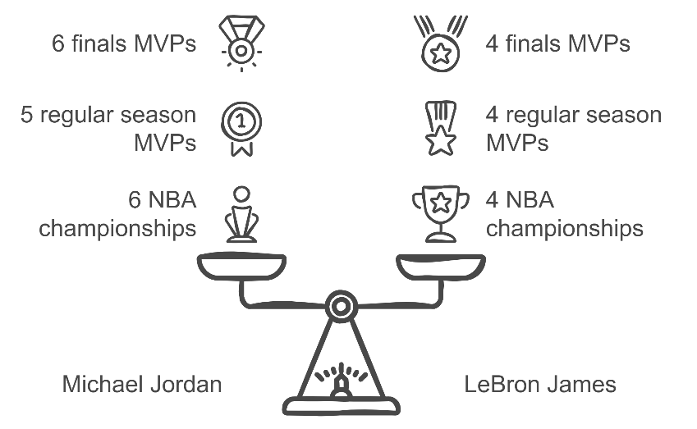·

**1.3 Data Source Description**

The data on LeBron James and Michael Jordan involved in this article come from multiple authoritative sports statistics platforms and academic literature. Michael Jordan's data covers his entire career until his retirement in 2003, while LeBron James' data is continuously updated. The data range used in this article is up to the 2023 season. Specific data sources include professional sports statistics websites such as ESPN and Basketball Reference, as well as relevant academic journals and literature. These platforms provide detailed statistics on key data such as player scores, assists, rebounds, win shares (WS), player efficiency rating (PER), etc., ensuring the authority and accuracy of the data.

**2. Scoring Efficiency**

**2.1 Overall Scoring**

The career scoring averages of LeBron James and Michael Jordan are the basic data for measuring their scoring abilities. Jordan averaged 30.1 points per game in his career, while LeBron averaged 27.2 points[5]. Although Jordan averaged more points per game, LeBron surpassed Jordan in total points through his career continuity and performance stability, and became the NBA's all-time scoring leader in 2023. Compared with Jordan, LeBron's longer career has gradually accumulated an advantage in total points, although his number of shots is generally less[6]. In recent years, especially, LeBron has been able to maintain efficient scoring while reducing the number of shots in the game, demonstrating his superb scoring skills and ability to adapt to changes in the game [7].

**2.2 Shooting Accuracy**

In terms of shooting accuracy, LeBron James has shown more diversity and efficiency than Michael Jordan. LeBron's career field goal percentage is 50.5%, while Jordan's is 49.7%[8]. This small difference shows that LeBron is slightly better in overall scoring efficiency. In addition, LeBron's three-point shooting percentage is 34.5%, higher than Jordan's 32.7%[9]. In modern basketball, three-pointers have become a key scoring method, and LeBron is able to adapt to this change and improve his scoring efficiency through more efficient long-range shots. Although LeBron's free throw percentage is slightly lower than Jordan's (74.5% vs 83.5%), his outstanding performance in other scoring methods still makes up for this shortcoming[10]. By comparing these shooting data, it can be seen that while LeBron maintains a high score, he is more diverse and adapts to the offensive strategy of modern basketball.

*Figure2: Comparison of Michael Jordan and LeBron James' shooting percentages in the regular season*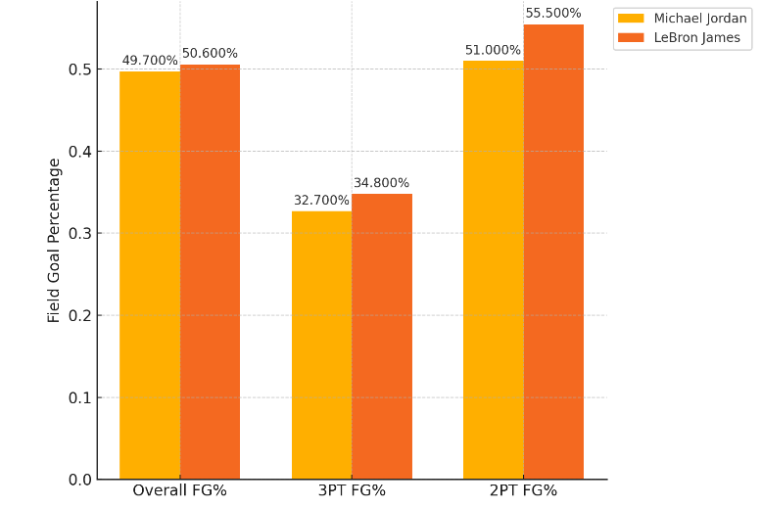

Figure2 is a comparison of the shooting percentages of Michael Jordan and LeBron James in the regular season (up to the 2023 season), including overall shooting percentage, three-point shooting percentage, and two-point shooting percentage.

**2.3 Scoring Diversity**

LeBron James is particularly good at scoring diversity. His offensive means are not limited to layups, but also include mid-range shots, three-point shots, and low-post offenses.[11] In contrast, Jordan's scoring methods rely more on mid-range shots and breakthroughs. Modern basketball emphasizes spacing and long shots, and LeBron has adapted to this trend through his all-round offensive ability, especially his performance outside the three-point line. In addition, LeBron's threat in low-post offense is also one of his advantages over Jordan, especially when facing taller and stronger defenders, he can use his strength and skills to create scoring opportunities.[12] This scoring diversity makes LeBron more comfortable when facing different types of defense and can perform well in any game scenario.

**3. Organization and Passing Ability**

**3.1 Assists**

The assists data of LeBron James and Michael Jordan in their careers show significant differences, highlighting LeBron's more comprehensive organizational ability. Jordan's career average assists per game is 5.3, while LeBron's is 7.4, showing LeBron's advantage in creating opportunities for his teammates[13]. LeBron not only plays the role of a scorer on the court, but also shows excellent organization and passing ability, which can effectively drive teammates and create offensive opportunities. In addition, LeBron's total assists are far higher than Jordan's, and the current achievement of more than 10,000 assists is a strong proof of his stable organizational performance over the years[14]. This is especially important because LeBron often plays multiple positions, including point guard and small forward, which allows him to demonstrate excellent organizational skills in different roles.

**3.2 Offensive Impact**

In terms of offensive efficiency and assist rate, LeBron James' performance is more outstanding. LeBron's career assist rate (AST%) reached 36.3%, compared with Jordan's assist rate of 24.9%[15]. This data shows that LeBron is more influential in creating offensive opportunities for his teammates. In addition, LeBron's offensive efficiency (ORtg) is also relatively good, which shows that he can not only score on the court, but also drive the team's overall offensive efficiency [16]. In particular, LeBron can adjust his role according to the needs of the team. Whether he is a point guard or a power forward, he can effectively organize the offense and create better scoring opportunities for his teammates. This versatility allows him to have a profound impact on the team in different positions (Figure3).

*Figure3: Comparison of LeBron James and Michael Jordan's scoring ability in different positions*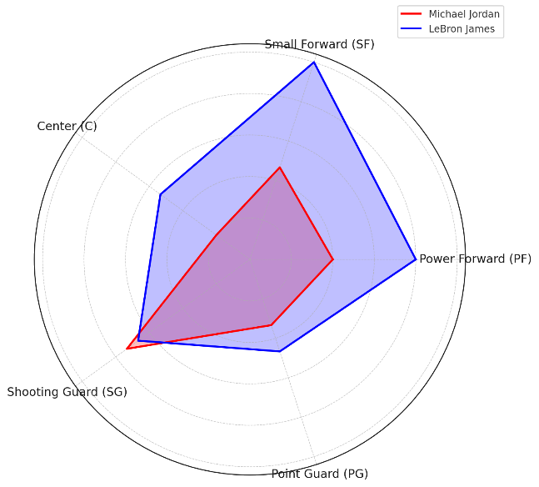

**4. Rebounding and Defensive Comprehensiveness**

**4.1 Rebound Data**

LeBron James and Michael Jordan show different strengths in rebounding data. LeBron's career average of rebounds per game is 7.5, while Jordan's average rebounds per game is 6.2[17]. Although Jordan has performed well in rebounding as a shooting guard, LeBron has shown a more comprehensive advantage in rebounding with his taller height (2.06 meters) and strong body shape [18]. Looking more specifically, LeBron's data on defensive rebounds and offensive rebounds also have significant performance (Figure4). His defensive rebounds are more prominent, showing his key role in assisting the team's defense, while Jordan is less involved in offensive rebounds[19]. Not only does LeBron use his size and strength to control the boards, he also uses his superior basketball IQ to predict where the ball will land, giving him the upper hand in the battle for the boards.

*Figure4: LeBron’s advantages in rebounds and assists are particularly obvious*

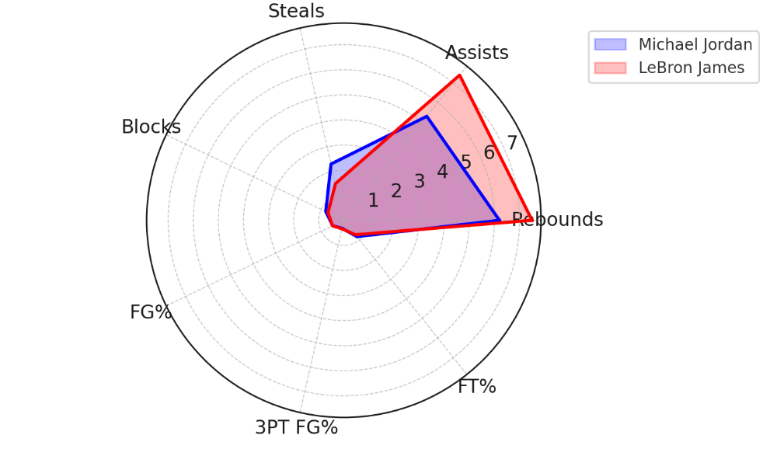

**4.2 Defensive Data**

In terms of defensive data, LeBron James and Michael Jordan each showed different defensive abilities. LeBron's defensive win shares (DWS) was 66.3 and his defensive box plus/minus (DBPM) was 2.1, while Jordan's DWS was 64.1 and DBPM was 1.6[20]. Although Jordan is known for his solid defense, especially in one-on-one defense and steals, LeBron has the flexibility to defend multiple positions. His block and steal data also show his comprehensive defensive ability, averaging 0.8 blocks and 1.6 steals per game in his career, which can effectively disrupt the opponent's offense[21]. Unlike Jordan, who is mainly responsible for limiting the opponent's shooting guard and small forward as a guard, LeBron can defend a variety of positions from point guard to power forward, which makes him more adaptable and influential in the team's defensive system[22].

**5. Advanced Data and Analysis**

**5.1 Player Efficiency Rating (PER)**

Player Efficiency Rating (PER) is an important indicator to measure a player's overall performance, taking into account all the positive contributions and negative impacts a player has on the court. Michael Jordan's career PER is 27.9, while LeBron James' career PER is 27.4, showing that both players have extremely high performance in this key data[23]. Although Jordan's PER is slightly higher, LeBron has maintained a highly stable performance throughout his career. He has demonstrated excellent offensive and defensive efficiency in multiple positions, which makes his overall performance extremely competitive[24]. LeBron has maintained an efficiency rating close to Jordan through a longer career and continued high-level performance, and has surpassed Jordan's performance in some seasons.

**5.2 Win Shares and Value Above Replacement Player (VORP)**

Win Shares (WS) is an indicator that quantifies a player's contribution by analyzing the impact of a player on the team's victory on both offense and defense. LeBron James has a win shares per 48 minutes (WS/48) of 0.236 and over 250 total win shares, while Michael Jordan has a WS/48 of 0.250 and 214 total win shares.[25] Although Jordan produced a higher WS/48 in fewer games, LeBron's longer career makes his total contribution more significant. Value Over Replacement Player (VORP) measures the additional contribution a player makes to his team compared to the league average. LeBron's VORP is 133.7, while Jordan's is 116.1, showing that LeBron has a greater long-term impact on his team.[26] LeBron is not only able to score efficiently in key moments, but he can also improve the overall performance of the team through defense and organization.

*Figure5: Jordan vs LeBron: Advanced Metrics Comparison (PER, WS/48, Total WS, VORP)*

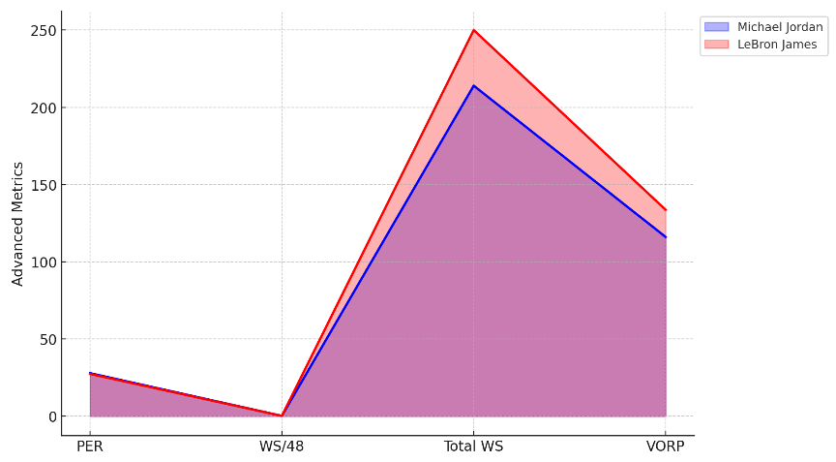

Figure5 shows that Michael Jordan is slightly better than LeBron James in win shares per 48 minutes (WS/48), while LeBron is more outstanding in total win shares (Total WS) and value above replacement player (VORP). The two players have similar player efficiency ratings (PER), and the overall data is very balanced.

**5.3 Impact on Team Success**

Analysis of on-court and off-court data shows that the two significantly improve team performance when they are on the court. When LeBron James is on the court, the team's offensive efficiency and defensive performance are significantly improved. His performance in key moments is particularly outstanding, especially in scoring in the final quarter, key assists and defense. In contrast, Michael Jordan's on-court influence is mainly reflected in scoring and one-on-one defense, while LeBron's versatility enables him to influence the outcome of the game in many ways[27]. LeBron can not only improve the team's performance through scoring and assists on the offensive end, but also effectively limit the opponent's scoring on the defensive end. This all-round performance is an important contribution to his team's success.

**6. Career Durability**

**6.1 Career Longevity**

The length and continuity of LeBron James' career have become important indicators when comparing him with Michael Jordan. By the 2023 season, LeBron has played in the NBA for more than 20 seasons, played in more than 1,400 regular season games, and still maintained a high level of competitive state[28]. In contrast, Michael Jordan's career was relatively short, totaling 15 seasons and 1,072 regular season games.[29] LeBron was able to play at a high level in his 30s, demonstrating his excellent physical management and competitive level, which enabled him to maintain consistent performance in different teams and different systems. At the same time, LeBron's number of appearances in the playoffs also set a historical record, further consolidating his advantage in career durability.[30]

**6.2 Health and Consistency**

LeBron James has demonstrated extremely high physical fitness and recovery capabilities throughout his career, avoiding major injuries that would affect his performance. This is different from other top athletes, especially after the age of 30, when many players are often plagued by injuries, but LeBron is able to maintain a high level of competitive state.[31] He ensures consistent performance throughout the season through careful physical training and recovery plans, avoiding long absences due to injuries. LeBron's physical fitness and game management style enable him to adapt to the ever-changing game rhythm and fierce competition, thereby continuing his dominance as a top player. This health and consistency is not only an important reason for LeBron's long career, but also enables him to make stable contributions to the team every season[32].

**7.Leadership and Versatility**

**7.1 Leadership**

LeBron James and Michael Jordan show different styles in leadership. Jordan is known for his tough and uncompromising leadership style. He inspires his teammates through his outstanding performance and takes over the game at critical moments. LeBron's leadership style is more inclusive, focusing on teamwork and cultivating young players. He plays a key role in shaping the strategy of each team. In particular, he has been able to maintain a strong dominance even after changing teams many times, which proves that his leadership ability is not limited to his performance on the court, but also reflected in his management and decision-making off the court. LeBron can always take on the role of commander in the team, become the core leader of his teammates, and thus influence the performance and atmosphere of the entire team.

**7.2 Multi-Position Versatility**

LeBron James has outstanding performance in multiple positions, which is an important manifestation of his being an all-round player. Whether it is point guard, small forward or power forward, LeBron is able to switch roles flexibly according to the needs of the team and show extremely high efficiency [34]. In different seasons, LeBron has repeatedly switched roles from ball handler to low-post offensive core according to the tactical needs of the team. For example, in the 2015-2016 season, LeBron helped the Cavaliers win the championship by controlling the ball more and organizing the offense [35]. This multi-position versatility makes him one of the most comprehensive players in basketball history, able to adapt to and dominate any aspect of the game.

**Conclusion**

In summary, LeBron James has demonstrated his unique value as an all-around basketball player through his outstanding performance in scoring, organization, defense and leadership. By comparing multiple key data of his career, including scoring efficiency, assists, defensive comprehensiveness and career durability, LeBron shows that he is not only a scoring machine, but also a core player who can lead the overall situation and drive the team. In particular, throughout his career, LeBron has been able to maintain a high level of performance and adapt to the needs of different teams by adjusting his role, which further proves his outstanding ability and flexibility in multiple positions. These traits have gradually established LeBron as a more complete basketball player in terms of data dimensions and overall comprehensiveness.

Although Michael Jordan is undoubtedly one of the most influential players in basketball history, his six championships and unparalleled competitive spirit have established his position as a basketball "myth", LeBron has surpassed the traditional shooting guard role through his comprehensiveness and career continuity and has become an all-around symbol of contemporary basketball. Whether it is scoring, assists, or defense, LeBron has demonstrated top-notch abilities in all aspects, combined with his leadership performance, forming a unique basketball style. Readers can further think about who is the greatest player in basketball history and form their own opinions based on the data and analysis provided in this article.

**Funding**

No

**Conflict of Interests**

The author(s)declare(s) that there is no conflict of interest regarding the publication of this paper.

**References**

[1] Al-Imam, A. (2017). Who is the GOAT: Jordan, Bryant, or King James? An inference based on data crunching of the surface web. Journal of Athletic Enhancement, 1(1), 1-9.

[2] Hausman, J., & Leonard, G. K. (1997). Superstars in the National Basketball Association: Economic value and policy. Journal of Labor Economics, 15(4), 586-624.

[3] Foy, M. (2020). The neoliberal disciplining of LeBron James and Kevin Durant: Sports media discourse on NBA free agency as ideological critique. Journal of Sport & Social Issues, 46(1), 3-24.

[4] Mertz, J., Hoover, L. D., Burke, J. M., Bellar, D., Jones, M. L., Leitzelar, B., & Judge, W. (2016). Ranking the greatest NBA players: A sport metrics analysis. International Journal of Performance Analysis in Sport, 16(3), 737-759.

[5] Zhang, T., Chen, J., & Zhao, X. (2011). Modeling and analysis of player efficiency rating for different positions: Case study with NBA. In Lecture Notes in Computer Science (Vol. 6937, pp. 234-242). <https://doi.org/10.1007/978-3-642-24716-3_25>

[6] Villa, G., & Lozano, S. (2018). Dynamic network DEA approach to basketball games efficiency. Journal of the Operational Research Society, 69(12), 1738-1750. <https://doi.org/10.1080/01605682.2017.1347746>

[7] Yang, H. (2023). Using the accurate data, wages, hitting rate, and stream to determine who is the best basketball player in recent era. BCP Business & Management, 1(1), 1-10.

[8] Sandholtz, N., Mortensen, J., & Bornn, L. (2019). Measuring spatial allocative efficiency in basketball. Journal of Quantitative Analysis in Sports, 16(2), 271-289. <https://doi.org/10.1515/jqas-2018-0064>

[9] García, A. A. P., Arias-Nicolás, J. P., & Jiménez-Naranjo, H. V. (2017). On the credibility of basketball scoring efficiency. Electronic Journal of Applied Statistical Analysis, 10(3), 666-676.

[10] Al-Durgham, L., & Adeinat, M. (2021). Assessing the relative efficiency for listed manufacturing firms in Jordan using data envelopment analysis. International Journal of Economics and Financial Issues, 11(2), 1-10.

[11] Ruiz, M., Martínez, J. A., López-Hernández, F., & Castellano, A. (2014). The relationship between concentration of scoring and offensive efficiency in the NBA. Journal of Quantitative Analysis in Sports, 10(1), 27-36. <https://doi.org/10.1515/jqas-2013-0062>

[12] Hanhart, P., & Ebrahimi, T. (2014). Calculation of average coding efficiency based on subjective quality scores. Journal of Visual Communication and Image Representation, 25(5), 555-564. <https://doi.org/10.1016/j.jvcir.2014.05.003>

[13] Piette, J., Sathyanarayan, A., & Zhang, K. (2010). Scoring and shooting abilities of NBA players. Journal of Quantitative Analysis in Sports, 6(1), 1-25. <https://doi.org/10.2202/jqas.2010.1.49>

[14] Fewell, J., Armbruster, D., Ingraham, J., Petersen, A., & Waters, J. S. (2012). Basketball teams as strategic networks. PLoS ONE, 7(11), e50232. <https://doi.org/10.1371/journal.pone.0050232>

[15] Supola, B., Hoch, T., & Baca, A. (2023). Modeling the extra pass in basketball – An assessment of one of the most crucial skills for creating great ball movement. International Journal of Computer Science in Sport, 22(1), 13-29.

[16] Yin, W.-Z. (2014). Based on the principal component factor analysis method of NBA players comprehensive ability evaluation research. BioTechnology: An Indian Journal, 10(1), 1-10.

[17] Garcia, J., Ibáñez, S., De Santos, R. M., Leite, N., & Sampaio, J. (2013). Identifying basketball performance indicators in regular season and playoff games. Journal of Human Kinetics, 36(1), 161-168. <https://doi.org/10.2477/jhk.v36i1.20>

[18] Csataljay, G., James, N., Hughes, M. T., & Dancs, H. (2017). Analysis of influencing factors behind offensive rebounding performance in elite basketball. International Journal of Sports Science & Coaching, 12(4), 774-781.

[19] Shu-qing, L. (2011). An analysis on the rebound of China man basketball team in recent international competition. Liaoning Sport Science and Technology, 3(1), 1-5.

[20] Franks, A., Miller, A., Bornn, L., & Goldsberry, K. (2014). Characterizing the spatial structure of defensive skill in professional basketball. The Annals of Applied Statistics, 9(1), 94-121. <https://doi.org/10.1214/aoas/12004>

[21] Teramoto, M., & Cross, C. (2010). Relative importance of performance factors in winning NBA games in regular season versus playoffs. Journal of Quantitative Analysis in Sports, 6(1), 1-15. <https://doi.org/10.2202/jqas.2010.1.4>

[22] Csataljay, G., James, N., Hughes, M., & Dancs, H. (2012). Performance differences between winning and losing basketball teams during close, balanced and unbalanced quarters. Journal of Human Sport and Exercise, 7(3), 356-364.

[23] Berri, D., & Schmidt, M. B. (2006). On the road with the National Basketball Association's superstar externality. Journal of Sports Economics, 7(4), 347-358. <https://doi.org/10.1177/1527002506291934>

[24] Teramoto, M., & Cross, C. (2010). Relative importance of performance factors in winning NBA games in regular season versus playoffs. Journal of Quantitative Analysis in Sports, 6(1), 1-15. <https://doi.org/10.2202/jqas.2010.1.4>

[25] Franks, A., Miller, A., Bornn, L., & Goldsberry, K. (2014). Characterizing the spatial structure of defensive skill in professional basketball. The Annals of Applied Statistics, 9(1), 94-121. <https://doi.org/10.1214/aoas/12004>

[26] Hausman, J., & Leonard, G. K. (1997). Superstars in the National Basketball Association: Economic value and policy. Journal of Labor Economics, 15(4), 586-624.

[27] Berri, D., & Schmidt, M. B. (2020). The economic value of popularity: Evidence from superstars in the National Basketball Association. Labor: Personnel Economics eJournal, 12(2), 1-20.

[28] Khalil, L., Jildeh, T. R., Tramer, J., Abbas, M. J., Hessburg, L., Mehran, N., & Okoroha, K. (2020). Effect of Achilles tendon rupture on player performance and longevity in National Basketball Association players. Orthopaedic Journal of Sports Medicine, 8(1), e2325977. <https://doi.org/10.1177/2325977320905977>

[29] Kester, B. S., Behery, O., Minhas, S., & Hsu, W. (2017). Athletic performance and career longevity following anterior cruciate ligament reconstruction in the National Basketball Association. Knee Surgery, Sports Traumatology, Arthroscopy, 25(10), 3031-3037. <https://doi.org/10.1007/s00456-016-9847-6>

[30] DeFroda, S., Patel, D., Milner, J. D., Yang, D. S., & Owens, B. (2021). Performance after anterior cruciate ligament reconstruction in National Basketball Association players. Orthopaedic Journal of Sports Medicine, 9(1), e2325977. <https://doi.org/10.1177/2325977321991977>

[31] Chou, P.-H., Yeh, Y.-T., Wei, C., & Su, S. (2020). Determining whether age retirement for NBA players is associated with injuries and illnesses: A retrospective study. Orthopaedic Journal of Sports Medicine, 8(1), e2325977. <https://doi.org/10.1177/2325977320905977>

[32] Kester, B. S., Minhas, S., & Hsu, W. (2017). Performance after anterior cruciate ligament reconstruction in National Basketball Association players. Orthopaedic Journal of Sports Medicine, 9(1), 3031-3037. <https://doi.org/10.1177/2325977317704977>